**Cross-country comparison of VET qualifications discussed at Cedefop workshop**

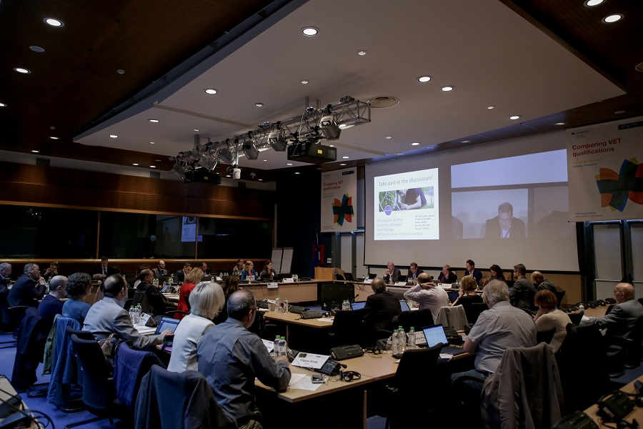

**Image copyright:**

© Cedefop, 2019/Sakis Gioumpasis

**Comparing the content of qualifications across European countries is part of Cedefop’s work on understanding qualifications, initiated more than two decades ago.**

It comprises the shift to learning outcomes to measure qualifications, the development of a common language (ESCO) to underpin a common understanding and the promotion of qualifications frameworks across Europe to classify them.

A workshop, organised by Cedefop on 28 and 29 November in Thessaloniki, explored yet another aspect of this consequential work: Can we develop reliable and scalable methods to map, analyse and compare the content of vocational education and training (VET) qualifications to better understand similarities and differences, strengths and weaknesses across borders?

Opening the workshop, Cedefop Executive Director Jürgen Siebel said that the agency has dedicated a project to comparing VET qualifications to fill a gap in the field.

Participants discussed the data sources on national qualifications, as concerns their content and profile, and the establishment of a common European reference system for comparing them. The debate focused on the differences between national skills priorities, and on how education and training systems respond to changing skills needs and to the internationalisation of labour markets and technologies.

While the key role of learning outcomes in the review and systematic comparison of qualifications was confirmed by participants, discussions revealed the gap between intended learning outcomes and the actual achievements of learners. There is a need for a better communication between the people who write learning outcomes into standards, programmes and curricula, the teachers and trainers who convey them and the employers who experience and monitor the actual learning outcomes.

Considering the sheer volume of the task of comparing qualifications across different countries, systems and languages, the elephant in the room throughout the workshop, parts of it will have to be automated. The building blocks of a computer-based methodology for comparing qualifications are being developed in the context of the project. ESCO will serve as a reference for a system prototype.

Participants concluded that a better alignment between education and training supply and labour market demand was needed. The dialogue between education and training professionals and employers needs to be closer. Some also highlighted the social partners’ role in defining qualifications and the need to have them on board.

It was stressed that considering the high number of refugees and skilled workers seeking employment in Europe, many EU Member States need to certify foreign workers’ qualifications and would welcome better descriptions and comparability. To ease the task, participants proposed to create clusters of skills, to start work at sectoral level only or to reflect on a new role for the Europas certificate supplement to allow jobseekers to provide more details on their skills. The elephant in the room will have to be, as one participant put it, eaten in small pieces.